Day-4
1.Create a shell script file and add shebang line.
Vi anil.sh
After open the file first line we have to check user which is used for code
#! /bin/bash means it is script runs using bash shell
Like other are there c shell, korn shell, bourne shell, z shell
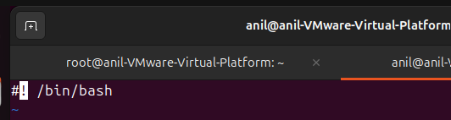

2.Write scripts for printing system information.
we can use this below command and get some information of the system which means hostname, os information, sytem uptime, and disk free of the system
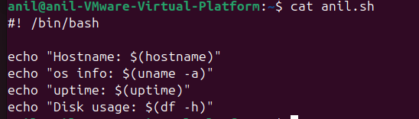
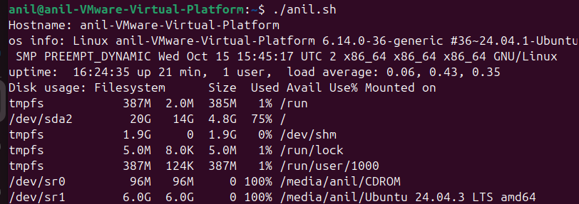

3.Use variables, conditionals, loops in scripts.
In this script I can use the variable “NAME” and then if condition in this condition statement file is exist it print the if part or else part will be display
I have used For loop condition to display the numbers
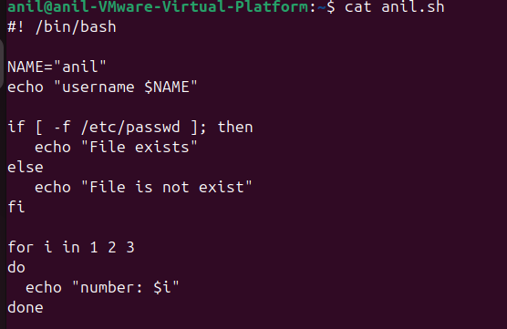

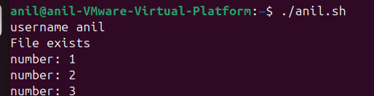

4.Automate log cleanup or backup tasks.
Auto log cleanup task
Used find command to find the log file and checked 7 days before file and deleted those file
find command, /var/log path , type file or directory, mtime modified time delete
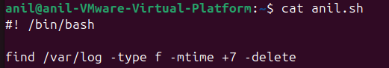
tar -cvzf backup.tar /home/anil/Documents
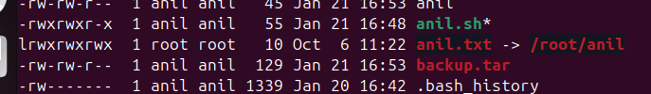

5.Make script executable and run it.
We have check the permission of the file , if execute permission is not then give execute permission for the script use the below command
Chmod +x file name or chmod 777 filename
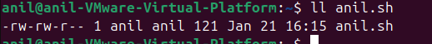
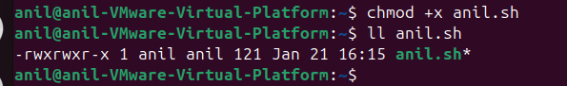
After run the script ./anil.sh it will display the information
We can full path /home/anil/anil.sh this called absolute path

6.Redirect output to files.
We can use > to redirect the output to file
>> to redirect the output to append the existing the input file
